Peltier Power Supply

The peltier’s thermoelectric device is current controlled. Its setup requires around 4 A of current with around 12V of input voltage. Therefore, for controlling the temperature of the TEC, we first need a way for either directly or indirectly controlling the current input to the device. Also, as we are reaching both higher and lower temperatures than room temperature, we need the power source to be bi-directional. To sum it up, we needed a high power current regulated bidirectional source.

To achieve this, we started by testing with BJT. We were able to control the current at low power, using normal BJT ICs. But we were unable to replicate the same result at higher power. The decision for using BJT was due to the fact that BJTs are called current controlled current sources, so if we could control the input current with a low pass filter and a pwm signal, we could be able to essentially control the output current. But due to the BJTs failure, we searched through literature for implementations of temperature control using peltier device. It was then that we came across Texas Instrument’s implementation using DRV595.

# Using DRV595 – A motor driver IC (H bridge)

DRV595 is an H-bridge IC. The speciality of this IC is that it can handle high power and provides internal switching for changing the directionality of the current. In principle the IC takes in analog differential input biased at 3.3V and amplifies it into corresponding PWM voltage output. This PWM output is then passed through a low pass filter to generate a final no ripple output.

The test board for testing this IC was designed. We faced many problems during its designing. This includes scaling down of the test board due to software differences, unavailability of proper inductors and inversion of the printed board. This caused many delays in conducting the testing. During the testing, we were not able to drive the IC out of the saturation region. Therefore, either we were getting zero output (at corresponding zero differential input) or we were getting the maximum output.

The testing conducted on DRV595 is further elaborated as follows:

1. The test board for DRV595 was made in reference to the Evaluation board developed by TI. The corner point of the design was the availability of power inductors for smoothening the output current.
2. Due to unavailability of inductors we connected 10 smaller value inductors in parallel to each other to meet the required specifications. This worked out to be just fine.
3. The exact procedure followed and the results obtained are as follows:
   1. Apply the following voltages:

The output obtained was around .

This is due to the fact that the IC was not turned on as PVcc < 5.6V (turn on voltage)

* 1. Now the circuit was powered up by applying .

The input applied remained the same, i.e.,

The average output was still around 0V.

This is due to the input differential voltage was still zero.

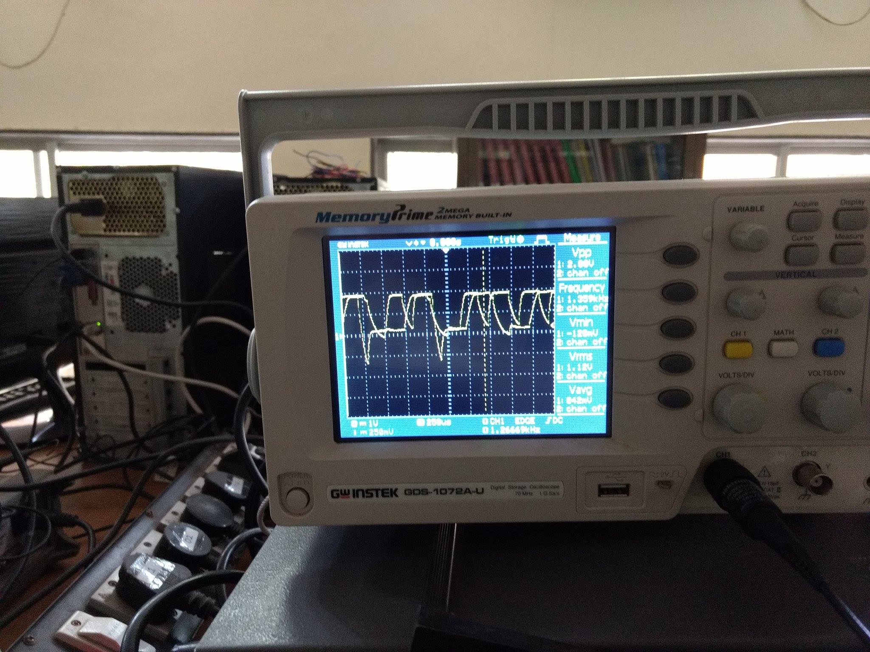

* 1. Note: The IC is biased to provide a gain of 1dB/V.

Now the differential voltage was given to be 0.1V.

Output in this case was saturated to 5.2V in spite of the fact that we connected a load at the output.

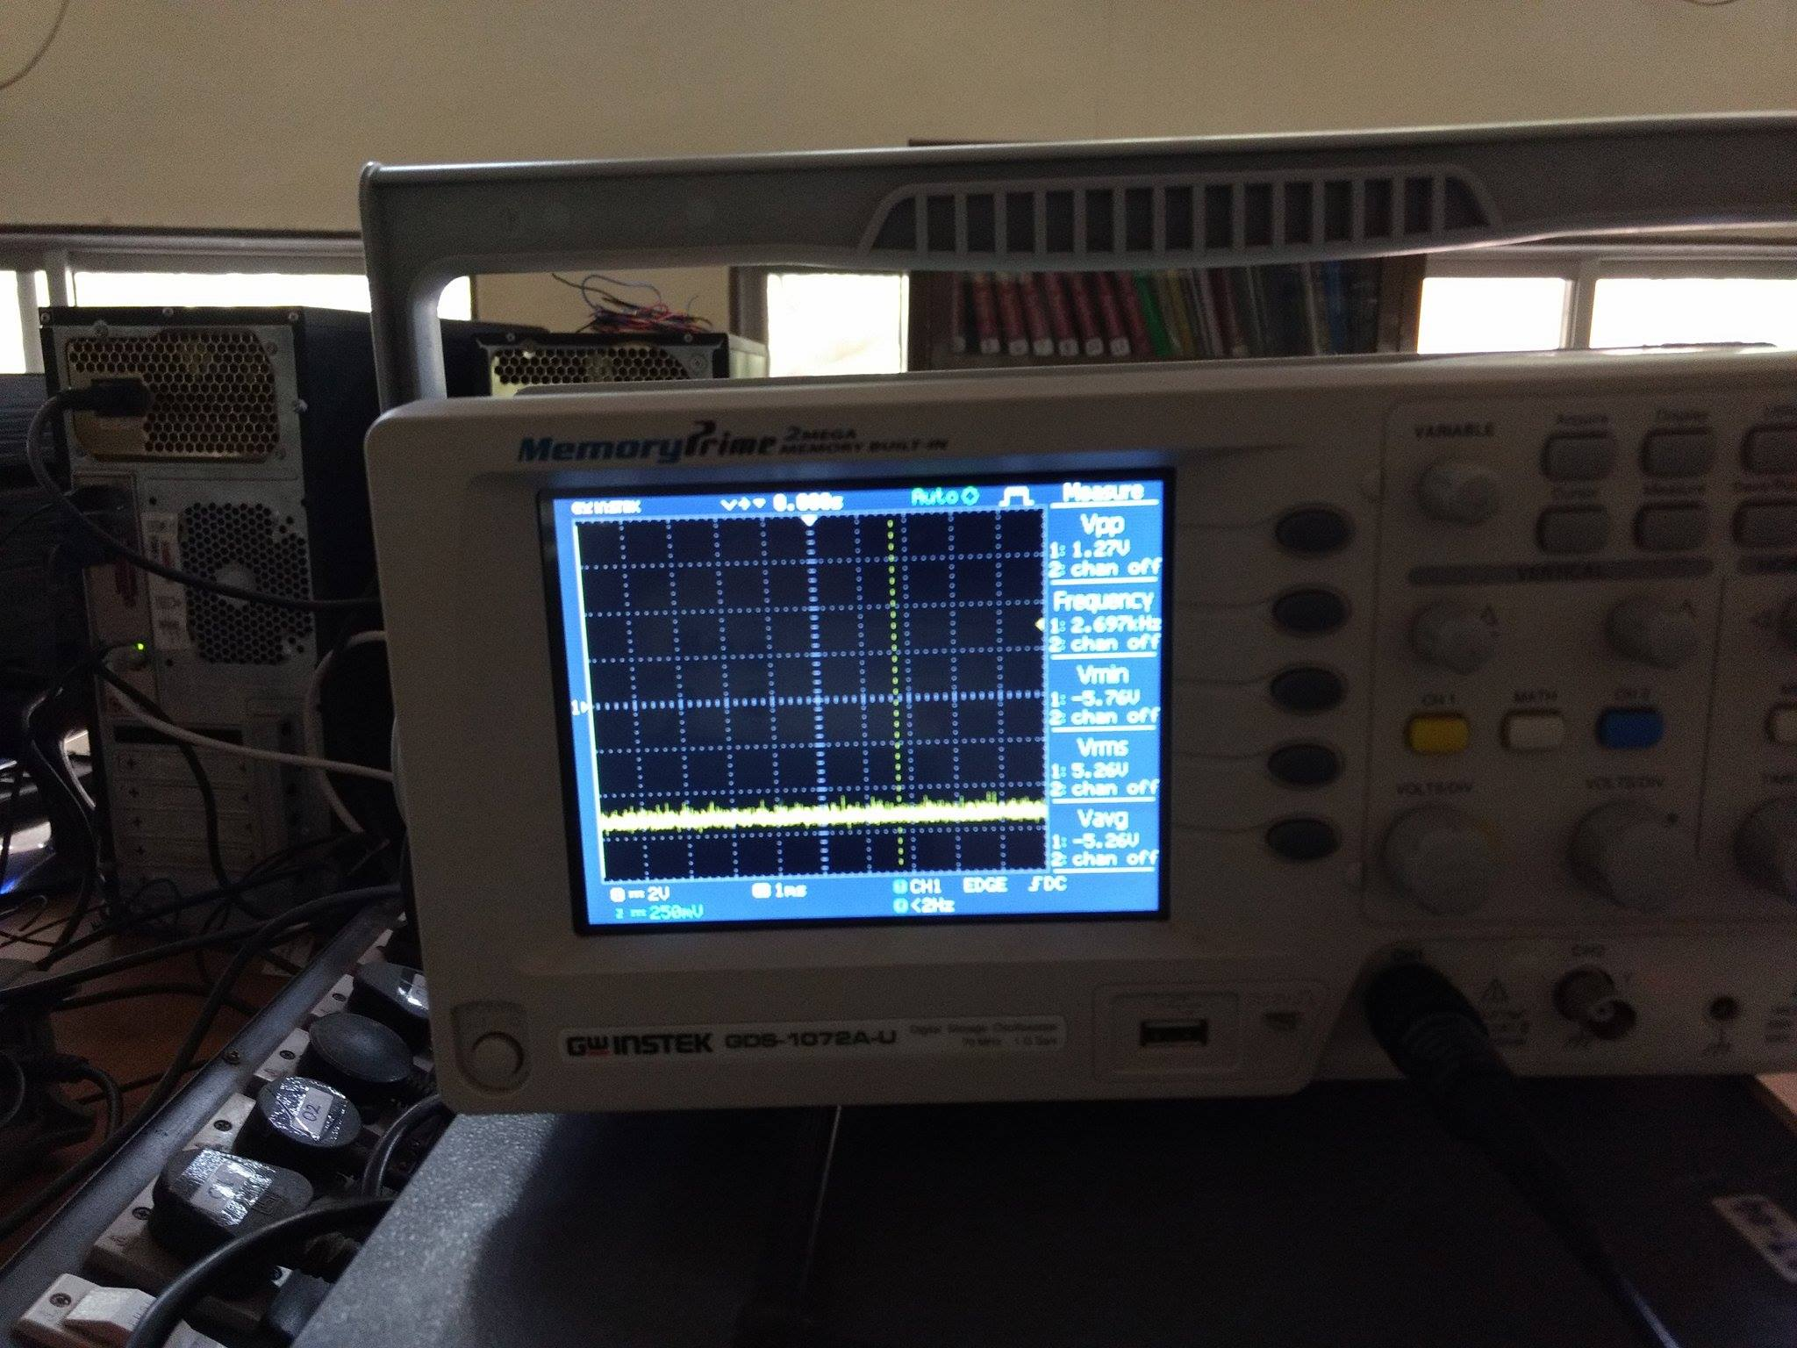

* 1. We tested multiple times and tried to drive the IC out of saturation, but were unsuccessful. Therefore, after spending considerable amount of time on the single IC we decided to shift onto the other best methods that could be used to achieve the goal.

Testing Notes:

* + - 1. At the start-up of the IC, IN+ and IN- must be held at equal voltages and above 3.3V. This must be ensured for at least a second for ensuring the correct working of the IC.
      2. Also keep an eye at the fault pin and the shutdown pin for checking the current mode of operation of the IC.

After the unsuccessful attempt at testing DRV595, we shifted our focus on using power MOSFETs for making an (indirect) current source. The idea of the MOSFET came from our mentor and other teams who have successfully implemented the same. There was a little shortcoming of getting ripple input to the peltier, but as the device worked, we continued with the implementation.

# Power supply for peltier

## Power MOSFET based Current Source

The MOSFET is used as a switching device for translating a low power PWM signal to an equivalent high power signal. The bi-directional requirement of the circuit is fulfilled with the help of two Relays connected in parallel.

This circuit can be understood in three steps:

1. Understanding the MOSFET operation: We have used IRFZ44N as the power MOSFET. It switches on at gate voltages greater than 10V. Now consider the following simplistic circuit for understanding it’s operation:

Low power 12V PWM

Peltier

12V power Source

Power MOSFET

High power 12V PWM

1. The micro-controller that we use provides 5V PWM. Therefore, we shifted the voltage level to 12V using a level shifter buffer.
2. This MOSFET is now connected in series to the TEC and the power supply. As the drain-source resistance of the MOSFET is very small, the power loss due to the same is also very small for a particular current flowing through the circuit. Also we can assume that it would not disturb the set point for the TEC.

The final flow chart for the same is as:



The following are the devices and components used in its implementation. These are pertaining to the schematic of the implementation circuit as shown on the schematic figure.

|  |  |  |
| --- | --- | --- |
| Bill of Materials | | |
| Component | Value (as Applicable) | Utility |
| C1 | 100uF | Low Pass filter capacitor |
| C2/C3 | 0.1uF | Decoupling capacitors |
| CONTROLS | Screw Connector | Control pins for switching relays |
| D1/D2 | 1N4004 | Relay Diode |
| D3/D4 | 1N914 | LM35 diode for biasing |
| FAN | Screw Connector | Power pins for the Fan |
| GATE_DRIVER | 7407N |  |
| INA_IN | Screw Connector | Input for INA for current sensing |
| INDUCTOR |  |  |
| JP1 | Jumper Wire |  |
| K1 | 351 |  |
| K2 | 351 |  |
| LM35 | Jumper Wire | Input from LM35 to the board |
| LSIN | Jumper Wire |  |
| LSJ1/ LSJ2/ LSJ3/ LSJ4 | Jumper Wire |  |
| PWM_RELAY_IN | Jumper Wire |  |
| Q1 | IRF520 | Power n-MOSFET |
| Q2 | IRF520 | Power n-MOSFET |
| R1 | 330 | Pull-up resistor |
| R2/R3 | 20K | Pull-down resistor |
| R4/R5/R6 | 3K | Pull-up resistors |
| RELAY_DRIVER | 7405N | Open collector buffer for driving the relays |
| SUPPLY | Screw Connector | 5V dc power supply |
| SUPPLY_1 | Screw Connector | +12V dc power supply |
| TEST_POINTS | Jumper Wire | Testing point |
| U$1 | INA260 | INA current sensing IC |
| U1 | TXS0108E_PW_20 |  |

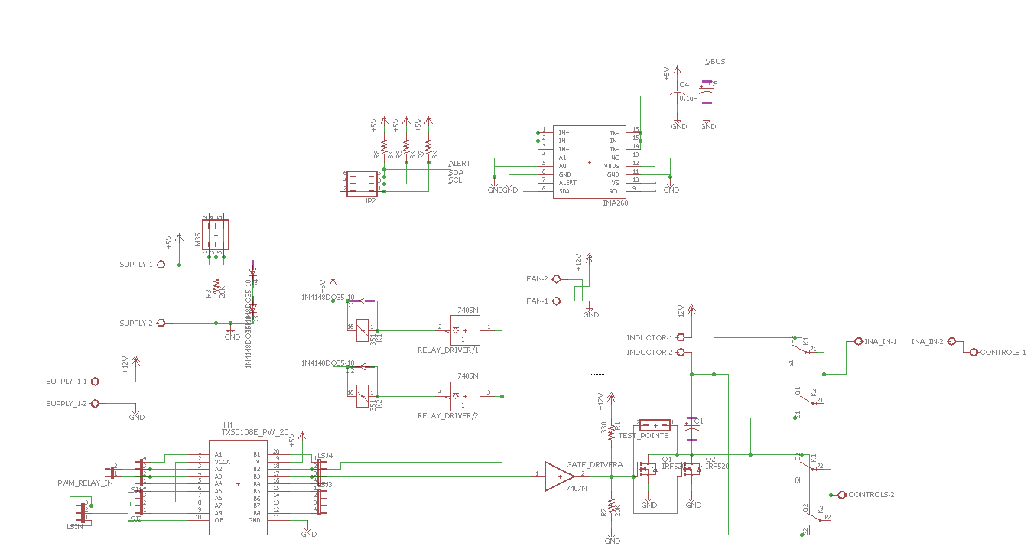

Details of the implementation are as:

* INA260 is used as a current sensing IC. It can measure current, input and power with high precision. It can be visualized as a combination of shunt resistor (of very small value), an ADC and an I2C bus. This IC was required as the availability of the low power dissipation precision shunt resistor was an issue. This issue arises due to the very high current which flows through the element.
* As a single relay does not meet the required power specifications, two relays are connected in parallel. Each relay has a specification of 2A. Diodes are connected in parallel to complete the relay (internal inductor) circuit, in order to avoid sparking at switching.
* The track size on the PCB is taken to be a minimum of 80mils. This is done in order to ensure that the amount of current that flows through the tracks is well supported.
* There are multiple level shifter buffers on the board. The conversion required is from 3.3V level (Tiva C) to 5V level (Relay Driver) and then from 5V to 12V level.
* We forgot to add power source on the PCB design for the INA, so we decided to use the external INA test board that was developed during the testing phase.
* The particular choice of the power MOSFET was due to the fact of easy availability in the WEL lab. Also, n-MOS was used instead of p-MOS due to low drain-source resistance of the n-MOS as compared to the p-MOS. We also did not make our own customized H-bridge using power p-MOS and n-MOS for the same reasons.
* As very high current is flowing through the MOSFETs, we used big heat sinks to account for the heat losses generated during the operation for further improving the performance.

Following is the image of the printed board

